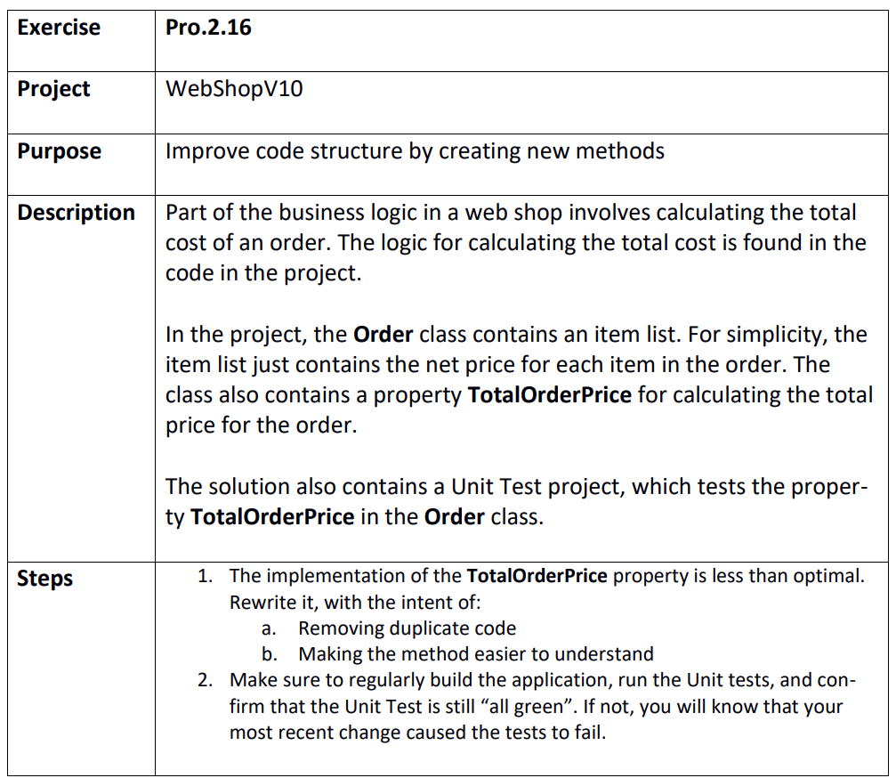

Step 1
WebShopV10.sln
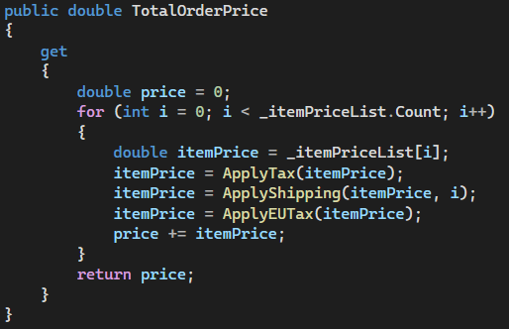

Step 2
Not all green because the unit test is genuinely wrong (Doesn’t do the logic described…)

